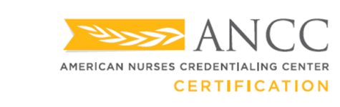

Success Pays®

Dear ,

Thank you for your application and your decision to use the Success Pays® program from American Nurses Credentialing Center (ANCC). We wish you the best of luck on your test!

Remember to arrive at least 15 minutes before your scheduled appointment time. If you arrive late, your session could interfere with the testing center’s schedule. Upon your arrival, you must present one form of acceptable identification from the list below (no photocopies will be accepted):

* Driver’s license issued by the Department of Motor Vehicles in one of the 50 states in the United States, the District of Columbia, or one of the U.S. territories
* State identification issued by the Department of Motor Vehicles in one of the 50 states in the United States, the District of Columbia, or one of the U.S. territories
* Passport
* U.S. military identification

Once you sit for the exam, immediately verify that you have the correct examination. Check the title and examination code on the cover/screen of the examination to make sure they match with the information the testing agency sent you.

For any additional questions, please be sure to refer to the [Certification General Testing and Renewal Handbook](https://www.nursingworld.org/~4ac3ba/globalassets/certification/renewals/GeneralTestingandRenewalHandbook). You may also contact us at 1.800.284.2378 or via email at [certification@ana.org](mailto:certification@ana.org).

Sincerely,