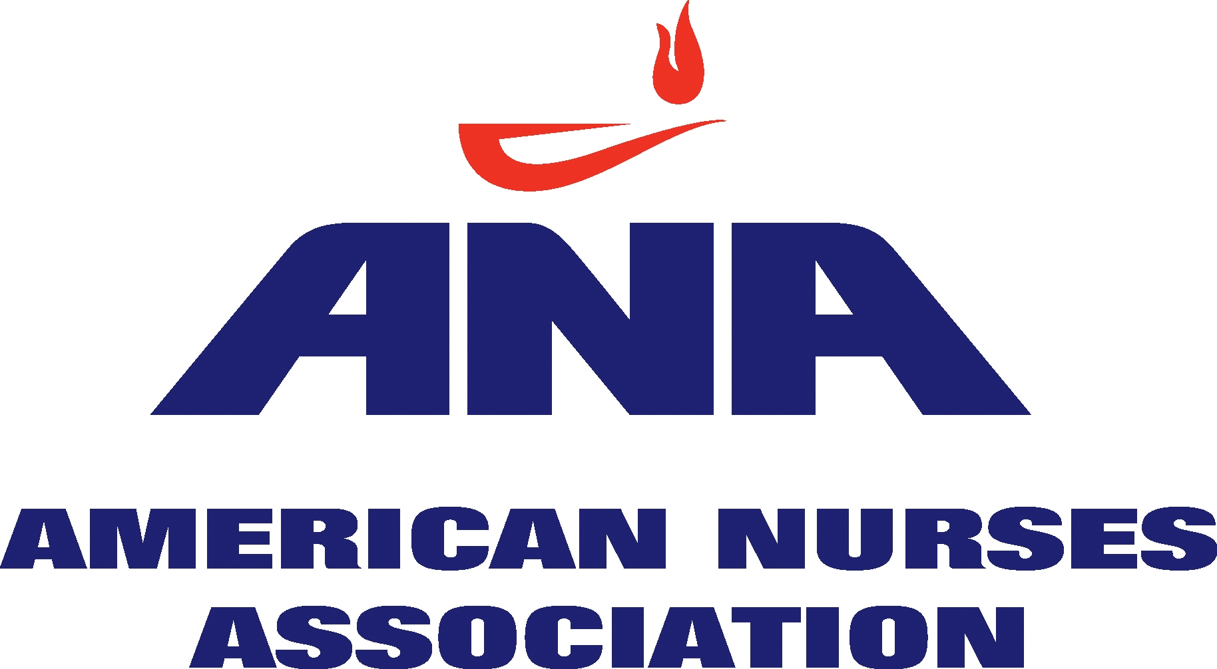

Responding to Proposed Changes in the Medicare Conditions of Participation (CoPs):
Medical Staff

Background and Guidance for APRNs

The Centers for Medicare and Medicaid Services (CMS) issued a proposed rule on October 24th that revises the requirements – commonly referred to as Conditions of Participation or “CoPs” - that hospitals must meet to participate in the Medicare and Medicaid Programs. CoPs are designed to protect patient health and safety and ensure quality of care, through specific requirements each hospital service or department must meet to participate in Medicare and Medicaid. CoPs are important because they serve as compliance guidelines for state surveyors, and minimum standards for private accrediting programs like the Joint Commission.

The deadline for submitting comments to CMS is December 23rd. ANA is making available draft comments and template letters in advance of that deadline in order to facilitate the submission of individual comments from our members. You will find those on the ANA website: www.nursingworld.org/conditionsofparticipation

There are several sections of these proposed revisions that are of interest to nursing. This document is intended to provide more background and guidance for APRNs who wish to comment on the proposed revisions to Section 482.22, Medical Staff. Please note that there are other sections of the proposed rule that APRNs may wish to comment on.

Do my comments really matter?
Yes! It is important that CMS staff understand how barriers to appropriate clinical privileges affect access to cost-effective, high quality care provided by APRNs. Write a concise paragraph that describes your practice and why clinical privileges are important. Describe any barriers you have faced to gaining appropriate clinical privileges. It is particularly important that CMS staff understand the importance of full medical staff privileges (ability to serve on key hospital committees, due process, etc.). If you hold one of the “alternate” designations noted (associate, special, limited, etc.) and find that problematic, provide a summary of those problems for CMS.

Do these proposed modifications represent a significant change that will facilitate credentialing and privileging of APRNs?
While helpful, these changes don’t make the significant changes we’d hoped for. T he American College of Nurse-Midwives (ACNM) took the lead on developing specific proposed modifications that would address the barriers typically faced by certified nurse-midwives (CNMs), certified midwives (CMs) and APRNs who seek clinical privileges. These changes, endorsed by ANA and the APRN community, were provided to CMS in the past year. They included a proposed requirement that “Practitioners shall be accorded clinical privileges and appointed to all categories of medical staff membership to the fullest extent allowed by State law, including admitting and discharge of patients, voting privileges and full due process…” Requirements were added to ensure that anyone seeking medical staff privileges would have their application acted upon within 60 days and that “decisions on clinical privileges and staff membership are based on an objective evaluation of an applicant’s credentials, free of anticompetitive intent or purpose.” These suggested revisions are not in the proposed rule published in October.

What modifications has CMS proposed?
CMS has added language to clarify that a hospital may grant privileges to both physicians and non-physicians to practice within their State scope of practice, regardless of whether they are also appointed to the hospital’s medical staff. Membership in a hospital’s medical staff would not be a prerequisite for granting practice privileges to practitioners. This is not new, but CMS felt that clarifying language was needed.

CMS notes that they have received questions about whether APRNs should be managed by human resources or the medical staff. They state that “technically, our current regulations already allow hospitals to appoint non-physician practitioners as members of their medical staffs, if the State law in which their hospital operates permits it. However, the numerous questions we have received in this area indicate that our current regulation is unclear. Therefore, we are proposing language to revise the section by clarifying that being a member of a hospital’s medical staff is not a prerequisite to being granted privileges in the hospital, regardless of whether a practitioner is a physician or a non-physician.”

CMS notes their concern that all practitioners working at a hospital should continue to follow the rules set forth for the Medical Staff. As a result, they have added language within this provision that would require physicians and non-physicians who have been granted practice privileges without appointment to the medical staff to be subject to the requirements contained within the Medical Staff section. “That is, they would be subject to the same hospital requirements, medical staff bylaws, and medical staff oversight as outlined under this CoP and to which appointed medical staff members are also subject.”

CMS also notes that hospitals could establish categories within the medical staff “to create distinctions between practitioners who have full membership and a new category for those who could be classified as having an “associate,” “special,” or “limited” membership.” CMS clarifies that this structure is provided as an example of a way to align all practitioners under the Medical Staff rules, but “such a structure is neither required nor suggested.” There is no acknowledgment of fact that in many hospitals, only members of the medical staff can hold important committee positions, vote on policies that affect practice, and be accorded due process.

The last change in this provision concerns direct responsibilities for the organization and accountability of the medical staff. Currently, the hospital may assign management tasks to an MD or DO, or when permitted by State law, a doctor of dental surgery or dental medicine. CMS adds doctors of podiatric medicine (DPMs) to this list.

CMS also considered a proposed change that would allow a multi-hospital system to have a single organized medical staff and are specifically seeking comment on this issue. “Stakeholders have reported that multi-hospital systems have both integrated their governing body functions and their medical staff functions to oversee patient care in a more efficient manner.” ANA has anecdotal evidence to suggest that when a hospital with a modern, progressive approach to clinical privileging and credentialing merges with another more restrictive hospital, APRNs have sometimes lost the gains they have accomplished. If this has been your experience, it would be particularly important for you to comment on this.

How are the Medicare CoPs related to Joint Commission (JC) Standards and Elements of Performance?
CMS has granted the JC what is known a “deeming authority.” In order to receive reimbursement from Medicare, hospitals must be evaluated by an accrediting body that has been granted deeming authority, or be evaluated by their state licensing agency on behalf of CMS. By granting deeming authority, CMS signifies that the accrediting organization’s standards meet or exceed those established by CMS. As such, hospitals that successfully complete the accreditation process are then deemed to meet CMS’ certification requirements.
CoPs serve as minimum standards for JC. Many aspects of credentialing and privileging that APRNs are familiar with (e.g. the definition and role of a licensed independent provider, or LIP; requirements for peer recommendation and for ongoing professional practice evaluation) are more detailed than CMS requirements and are spelled out in the JC Comprehensive Accreditation Manual for Hospitals (CAMH).

Does the Magnet Recognition Program® address how APRNs are credentialed?
The Magnet Recognition Program® includes the following Organizational Overview Item:
A description of the process by which the CNO or his or her designee participates in credentialing, privileging, and evaluating advanced-practice nurses. Include the frequency of re-privileging.
Just as there are a variety of mechanisms for credentialing and privileging APRNs (as members of the Medical Staff as well as through Human Resources), there are a variety of ways in which CNOs participate in the credentialing process at Magnet hospitals. This organizational overview item does not preclude any particular mechanism for credentialing APRNs.

ANA members with questions can contact:
Lisa Summers, CNM, DrPH
Senior Policy Fellow
Department of Nursing Practice & Policy
301-628-5058
Lisa.summers@ana.org

